RESOLUTION NO.__________

RE: CERTIFICATE OF APPROPRIATENESS UNDER THE
PROVISIONS OF THE ACT OF THE PENNSYLVANIA
LEGISLATURE 1961, JUNE 13, P.L. 282 (53
SECTION 8004) AND BETHLEHEM ORDINANCE NO.
3952 AS AMENDED.

WHEREAS, it is proposed to replace a portion of sidewalk along 89-91 W. Church St. and install a campus identification sign at the Brethren’s House entry area.

NOW, THEREFORE, BE IT RESOLVED by the Council of the City of Bethlehem that a Certificate of Appropriateness is hereby granted for the proposal.

Sponsored by: (s)

(s)

ADOPTED BY COUNCIL THIS DAY OF

(s)
President of Council

ATTEST:

(s)
City Clerk

HISTORICAL & ARCHITECTURAL REVIEW BOARD

The applicant is proposing to replace a portion of sidewalk along 89-91 W. Church St. and install a campus identification sign at the Brethren’s House entry area.
APPLICATION #3:

Moravian College
1200 Main Street
Bethlehem, PA 18018

OWNER:

__________________________________________________________________________

The Board upon motion by Phil Roeder and seconded by Marsha Fritz adopted the proposal that City Council issue a Certificate of Appropriateness for the following:

- Replace sidewalk with brick pavers. Main walkway would be a herring bone pattern with a running bond pattern adjacent to the curb.

- The campus sign design will be similar to existing sign at the northern campus but in a smaller scale.

- Materials of the paving and sign will match the masonry of the Brethren’s house.

- Sign to be a cast stone panel with incised lettering with letters painted black and a metal plaque for the back of the sign.

- Landscaping to be low height plants.

- Brick pavers will be Jamestown by Glen-Gery and Augusta brick for the sign. Stone and mortar to match the building. Background color of the sign panel to match the name panel on the building façade.

7. The motion was unanimously approved.
__________________________________________________________________________

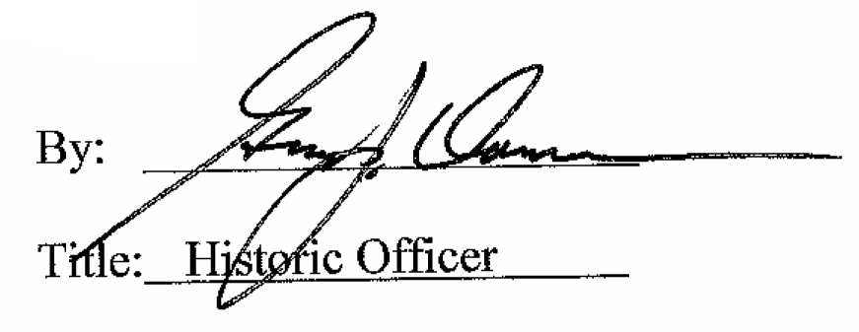

Date of Meeting: December 7, 2016

